K L UNIVERSITY
FRESHMAN ENGINEERING DEPARTMENT

A Project Based Lab Report On
SMART LOAN CALCULATOR
& PREPAYMENT SIMULATOR

TRACKING SYSTEM

SUBMITTED BY:

ID NUMBER NAME
2500031506 CH.BHARGAV
2500031785 Shaik saifuddin
2500031462 Nalla Sirisha

UNDER THE ESTEEMED GUIDANCE OF Mr REPUDI PITCHIAH
ASSISTANT PROFESSOR



KL UNIVERSITY
Green fields, Vaddeswaram – 522 502 Guntur Dt., AP, India.

DEPARTMENT OF BASIC ENGINEERING SCIENCES



CERTIFICATE

This is to certify that the project based laboratory report entitled “ONLINE ORDER PROCESSING AND TRACKING SYSTEM” submitted by CH.BHARGAV bearing Regd. No. 2500031506 to the Department of COMPUTER SICENCE ENGINEERING , KL University in partial fulfillment of the requirements for the completion of a project based Laboratory “Python program (25SC2007)” course in I B Tech I Semester, is a Bonafede record of the work carried out by him/her under my supervision during the academic year 2024 – 2025.

Mr REPUDI PITCHIAH Dr. D. HARITHA
PROJECT SUPERVISOR HEAD OF THE DEPARTMENT

ACKNOWLEDGEMENTS

It is great pleasure for me to express my gratitude to our honorable President.

Sri. Koneru Satyanarayana, for giving the opportunity and platform with facilities in accomplishing the project-based laboratory report.
I express sincere gratitude to our Director Dr. A. Jagdeesh for his administration towards our academic growth.
I express sincere gratitude to our Coordinator and HOD-BES Dr. D. Haritha for her leadership and constant motivation provided in successful completion of our academic semester. I record it as my privilege to deeply thank you for providing us with the efficient faculty and facilities to make our ideas into reality.
I express my sincere thanks to our project supervisor Mr REPUDI PITCHIAHfor her novel association of ideas, encouragement, appreciation, and intellectual zeal which motivated us to venture this project successfully.
Finally, we are pleased to acknowledge our indebtedness to all those who devoted themselves directly or indirectly to making this project a success.

ID NUMBER NAME

2500031506 CH.BHARGAV

ABSTRACT

EMI Master is a smart loan calculator and prepayment simulator designed to empower borrowers with comprehensive financial insights. This intuitive Python-based tool goes beyond simple EMI calculations, offering advanced features like amortization schedules, prepayment simulations, and comparative analysis of different loan scenarios.

The platform supports multiple loan types and interest calculation methods, ensuring accurate results regardless of the loan structure. With EMI Master, users can visualize the long-term impact of their financial decisions, compare various prepayment strategies, and optimize loan repayment for maximum savings. The tool also integrates tax benefit calculations under Section 80C and Section 24, enabling users to understand the true post-tax cost of their loans.

A key highlight of the project is its Prepayment Simulator, which demonstrates how even small additional monthly payments can result in significant interest savings — for example, a ₹10,000 extra monthly payment on a ₹50 Lakh loan at 6.5% over 20 years can save over ₹65 Lakhs in interest and reduce the tenure by 4 years. EMI Master helps users make smarter financial decisions through data-driven insights.

Key Words:
EMI, Loan Calculator, Prepayment Simulator, Amortization Schedule, Python, Financial Planning, Interest Rate, Principal, Tenure.

INDEX

S.NO | TITLE | PAGE NO
1 | Introduction | 6
2 | Aim of the Project | 7
2.1 | Advantages & Disadvantages | 8
2.2 | Future Implementation | 8
3 | SYSTEM REQUIREMENTS | 9
4 | FLOW CHART FOR EMI CALCULATION | 10
5 | Algorithm for each module | 11
6 | Implementation | 12-13
7 | Integration and System Testing | 14
8 | Conclusion | 15

1.INTRODUCTION

Managing loans effectively is one of the most critical aspects of personal financial planning. With the rise of home loans, car loans, personal loans, and education loans in India, millions of borrowers struggle to understand the true cost of their borrowings and the impact of different repayment strategies. EMI Master was conceived to address this challenge by providing a comprehensive, user-friendly tool that brings financial clarity to the common borrower.

Equated Monthly Installment (EMI) is the fixed monthly payment made by a borrower to a lender. It consists of both the principal repayment and interest. Understanding how EMIs work, how they are calculated, and how extra payments affect the loan is essential for sound financial management.

EMI Master is a Python-based application that:
- Calculates accurate EMIs for home loans, car loans, personal loans, business loans, and education loans.
- Generates detailed month-by-month amortization schedules.
- Simulates the impact of prepayments (extra monthly payments or lump-sum payments).
- Compares two key prepayment strategies: Reduce Tenure vs. Reduce EMI.
- Calculates tax benefits under Section 80C and Section 24 for home loans.

The project aims to make financial planning accessible and transparent for every Indian borrower, helping them save lakhs of rupees through informed decision-making.

2.AIM

The primary aim of EMI Master is to develop an intelligent and accurate loan management tool that goes beyond basic EMI calculation. The project targets the following objectives:

- To provide accurate EMI computation using both the Reducing Balance Method and Flat Rate Method.
- To generate complete amortization schedules showing the principal and interest split for every EMI payment.
- To simulate prepayment scenarios and quantify the resulting savings in interest and reduction in loan tenure.
- To compare 'Reduce Tenure' and 'Reduce EMI' prepayment strategies side-by-side.
- To integrate tax benefit calculations for home loan borrowers as per Indian tax laws.
- To present data-driven insights that help users make optimal financial decisions.

2.1 ADVANTAGES

- Provides accurate, multi-scenario financial analysis in one tool.
- Saves potential lakhs of rupees through guided prepayment strategies.
Supports all major Indian loan types with specific parameters..

2.1 DISADVANTAGES

- Does not account for lender-specific prepayment penalties.
- Tax benefit calculations are based on current Indian tax law and may require updates.
- Currently a command-line/console application; no graphical user interface.
.

2.2 FUTURE IMPLEMENTATION

- Develop a web-based or mobile GUI for better user experience.
- Add real-time interest rate data integration from RBI/bank APIs.
- Include investment vs. prepayment comparison module.
- Support for floating-rate loan EMI recalculation.
Multi-language support for regional accessibility

3.SYSTEM REQUIREMENTS

3.1 SOFTWARE REQUIREMENTS:
- Programming Language: Python 3.x
- Libraries: math, tabulate, csv (standard Python libraries)
- Operating System: Windows 10 / Ubuntu 20.04 or above / macOS
- IDE: VS Code, PyCharm, or any Python-compatible editor
- Python Interpreter: 3.8 or above
3.1 HARDWARE REQUIREMENTS:
- Processor: Intel Core i3 or above
- RAM: 4 GB minimum (8 GB recommended)
- Storage: 500 MB free disk space
- Display: 1280 x 720 resolution or higher

4. FLOW CHART FOR EMI CALCULATION

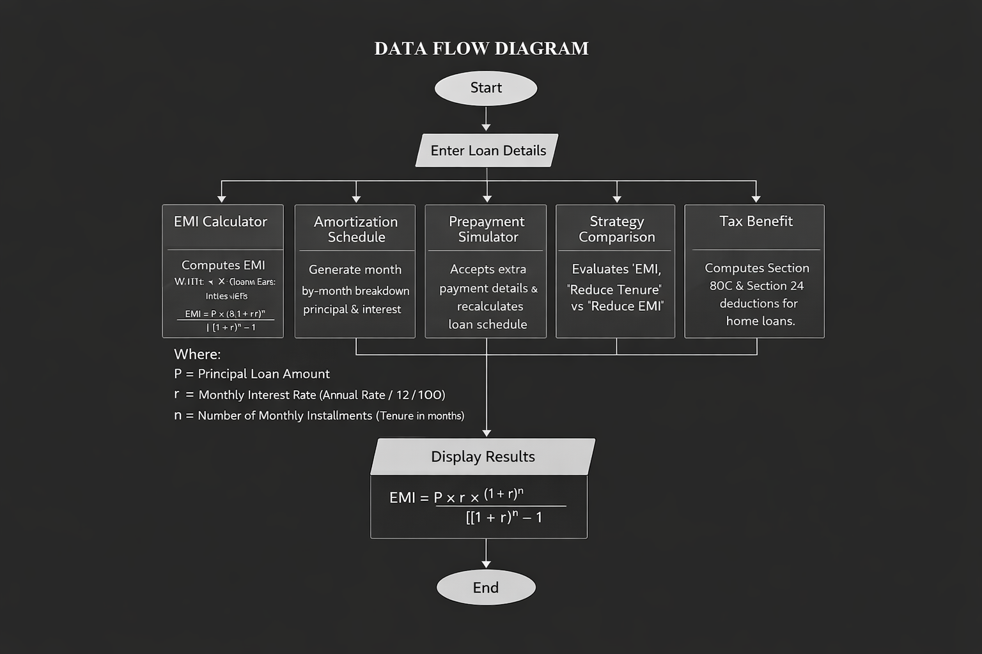

5.ALGORITHM FOR EACH MODULES

Module 1: EMI Calculator
Step 1: Start.
Step 2: Input loan_amount, annual_rate, tenure_years, loan_type.
Step 3: Compute monthly_rate = annual_rate / 12 / 100.
Step 4: Compute n = tenure_years × 12.
Step 5: If monthly_rate > 0, EMI = loan_amount × monthly_rate × (1+monthly_rate)^n / ((1+monthly_rate)^n − 1).
Step 6: Else EMI = loan_amount / n (zero interest case).
Step 7: Display EMI, total payment, total interest. Step 8: Stop.

Module 2: Amortization Schedule
Step 1: Start with balance = loan_amount.
Step 2: For each month from 1 to n:
a. interest_component = balance × monthly_rate
b. principal_component = EMI − interest_component
c. balance = balance − principal_component
d. Record month, EMI, principal, interest, balance.
Step 3: Display complete schedule. Step 4: Stop.

Module 3: Prepayment Simulator
Step 1: Accept extra_payment amount and strategy (reduce_tenure / reduce_emi).
Step 2: Recalculate schedule with modified payments each month.
Step 3: If reduce_tenure: keep EMI same, add extra to principal each month.
Step 4: If reduce_emi: recalculate EMI after each prepayment on reduced balance.
Step 5: Compute interest_saved = original_interest − new_interest.
Step 6: Compute months_saved. Step 7: Display comparison. Step 8: Stop.

6.IMPLEMENTATION

Code EMI Calculator Function

def emi_calc(p, r, t):

r, n = r/12/100, t*12

emi = p/n if r==0 else p*r*(1+r)**n/((1+r)**n-1)

return round(emi,2), round(emi*n,2), round(emi*n-p,2)

def schedule(p, r, t):

r, n = r/12/100, t*12

emi,_,_ = emi_calc(p, r*12*100, t)

b = p

for m in range(1,4): # only first 3 months

i = round(b*r,2)

pr = round(emi-i,2)

b = round(b-pr,2)

print(m, emi, pr, i, max(b,0))

def prepay(p, r, t, extra):

r, n = r/12/100, t*12

emi,_,oi = emi_calc(p, r*12*100, t)

b, ti, m = p, 0, 0

while b>0:

i = b*r

ti += i

b -= (emi-i+extra)

m += 1

return round(oi-ti,2), n-m

# -------- MAIN --------

p = float(input("Loan: "))

r = float(input("Rate: "))

t = int(input("Years: "))

emi, total, interest = emi_calc(p, r, t)

print("\nEMI:", emi, "Total:", total, "Interest:", interest)

print("\nFirst 3 Months:")

schedule(p, r, t)

extra = float(input("\nExtra Payment: "))

saved_i, saved_m = prepay(p, r, t, extra)

print("Saved Interest:", saved_i, "Months Saved:", saved_m)

7. INTEGRATION AND SYSTEM TESTING
OUTPUTS

Screen Shots:

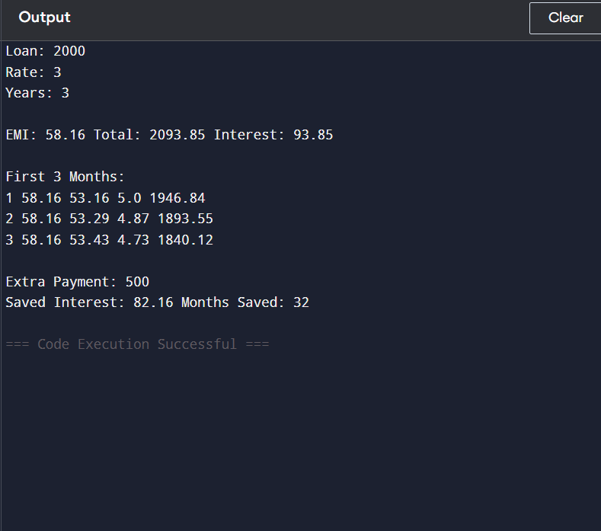

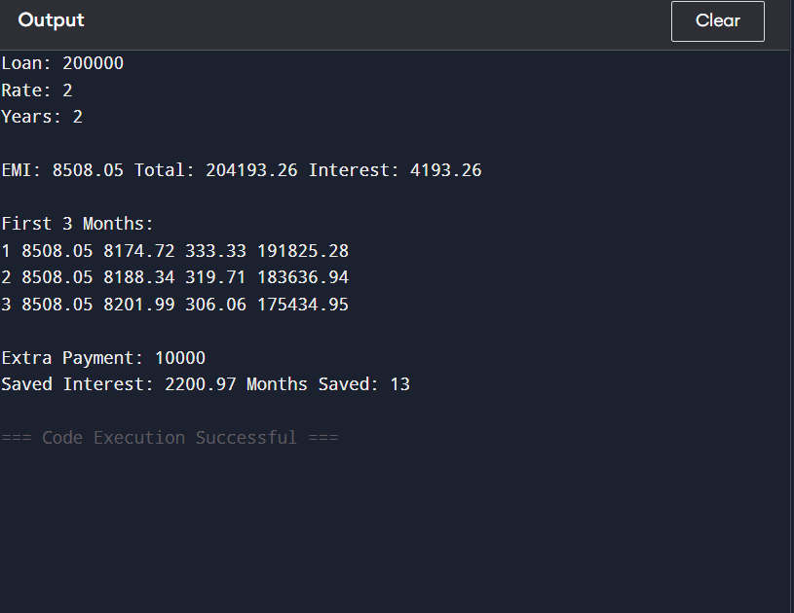

8.CONCLUSION
EMI Master successfully demonstrates how a thoughtfully designed Python application can solve real-world financial problems for millions of Indian loan borrowers. The project integrates all four core modules — EMI Calculator, Amortization Schedule Generator, Prepayment Simulator, and Strategy Comparison Tool — into a cohesive system that delivers clear, actionable financial insights.

The real-world data used in the project powerfully illustrates the importance of prepayment planning. For a ₹50 Lakh home loan at 8.5% over 20 years, the borrower pays ₹54.14 Lakhs purely as interest — more than the principal itself. With smart prepayment strategies simulated by EMI Master, such borrowers can save lakhs and become debt-free years earlier.

Through this project, the team gained practical experience in applying Python programming to financial computation, developing modular and reusable code, and translating mathematical formulas into functional software. The project also reinforced the importance of financial literacy in everyday life.

